Introduction
This report examines the design and analysis of simply supported steel beams under specific loading conditions, as specified in Short Project Opportunity 2. To ensure compliance with industry standards and safety requirements, materials are tested in terms of performance and economics the benefits of the trees look. Their ability to resist bending, shear forces and external loads makes them indispensable in structures such as buildings and bridges

The main objective of this study is to determine the adequacy of a given steel beam when subjected to a uniformly distributed load (UDL) It evaluates its behaviour, internal capacity and flexural behavior to ensure that it can safely support the applied loads without compromising the structural integrity It also emphasizes the importance, which is key to a practical and cost-effective solution study in civil engineering

The Kiran 360 UB analyzed in this report is a section of 50.7, which was chosen for its compact design and heavy-duty applications. The design process follows the principles of balance and construction engineering, ensuring that the beam meets performance standards under given conditions Uniformly distributed load, throughout the length of the beam, exhibits a typical condition meet in systematic applications have been demonstrated, making this research suitable for broadening various technical contexts

In addition to the technical analysis, this report provides a detailed cost estimate breaking down the costs associated with purchasing materials, labor, equipment, overhead and other indirect costs This approach ensures that it is not the design is not only appropriate but also economically viable, in line with industry practices and project budget requirements.

The report emphasizes the importance of combining theoretical analysis with practical considerations, such as resource management and process improvement. By addressing the technical and economic aspects of the project, this study presents a holistic approach to civil engineering design, emphasizing safety, reliability and cost-effectiveness This study contributes to understanding steel frames practices significantly, and provide valuable insights for future projects in architectural design and construction

Table of contents :

- Occasion -1 ………………………………………………………………………… 4

- Occasion -2………………………………………………………………………… 11

- Cost estimation ………………………………………………………………… 15

- References ……………………………………………………………………….. 16

- Occasion 1:
Design of Steel I beam for Second Moment of Area and Elastic Section Modulus: In this scenario you will be analysing the provided Steel I beam to perform certain calculations on the beam.

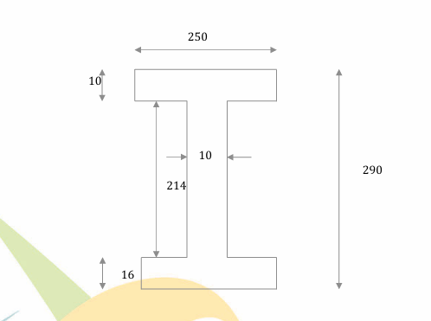
( steel beam )
Answer :

Given details :
Total depth = 0.290m
Width of flange = 2.250m
Thickness of flang = 0.100m
Thickness of web – 0.016m

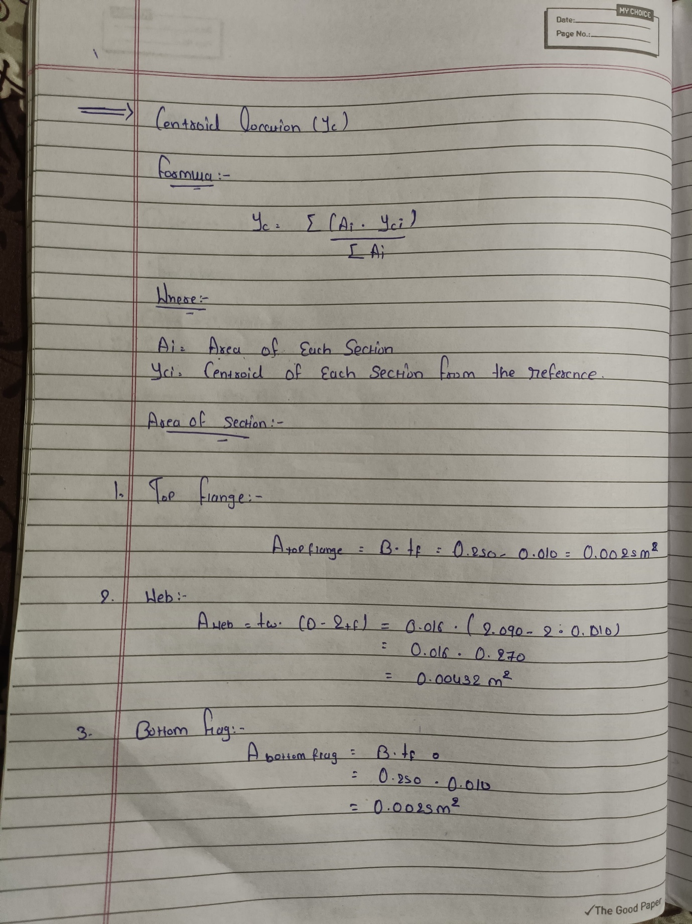

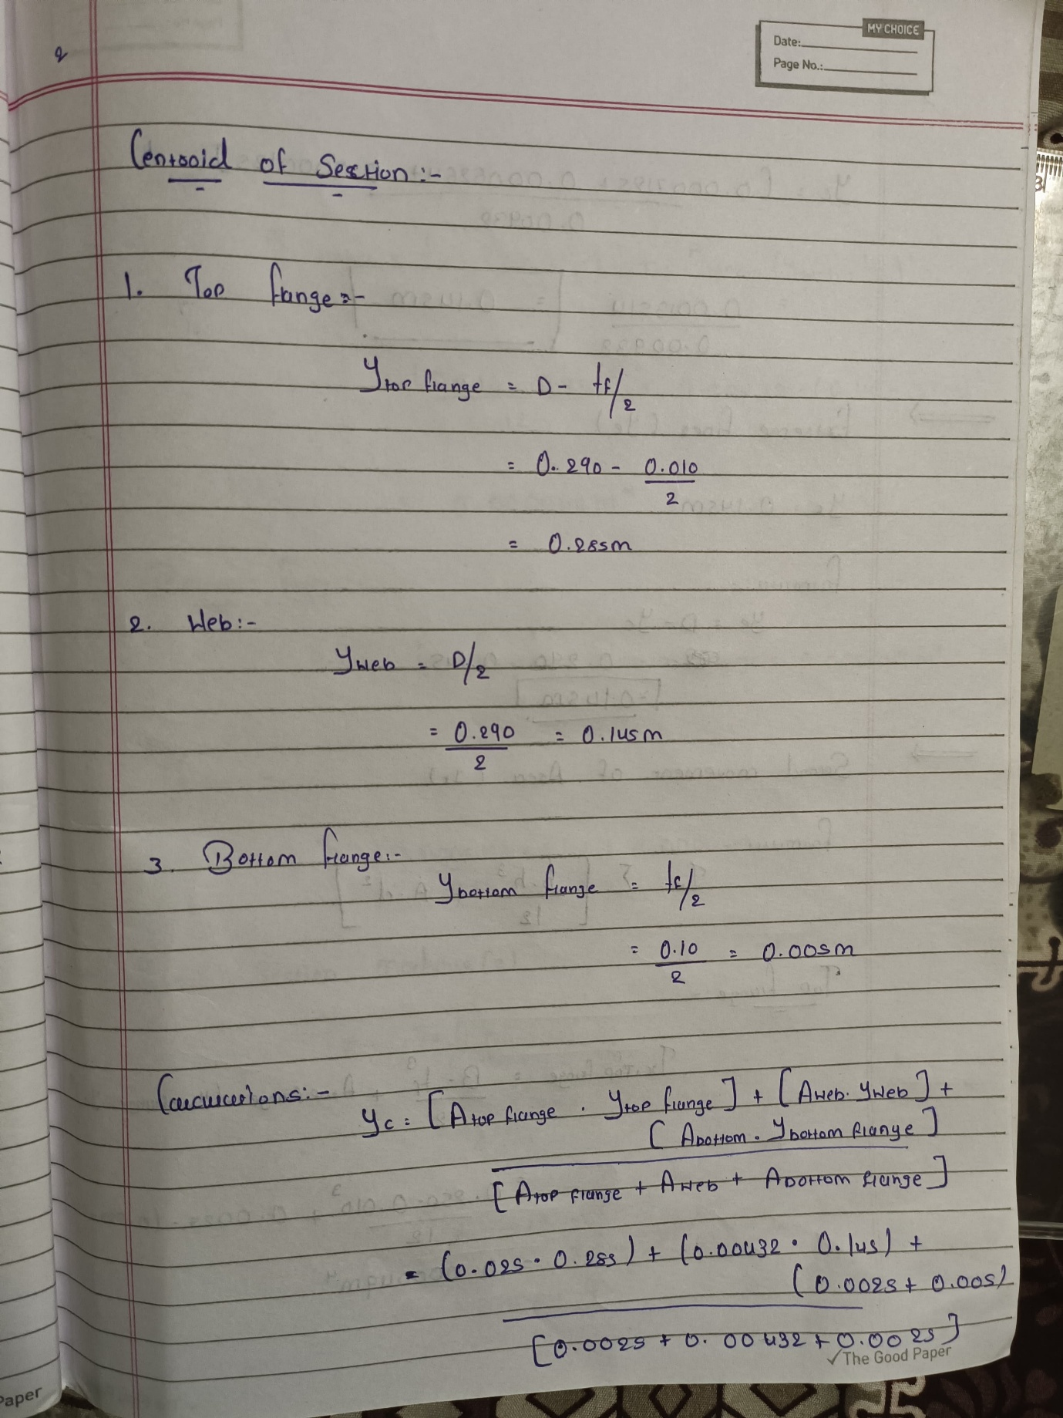

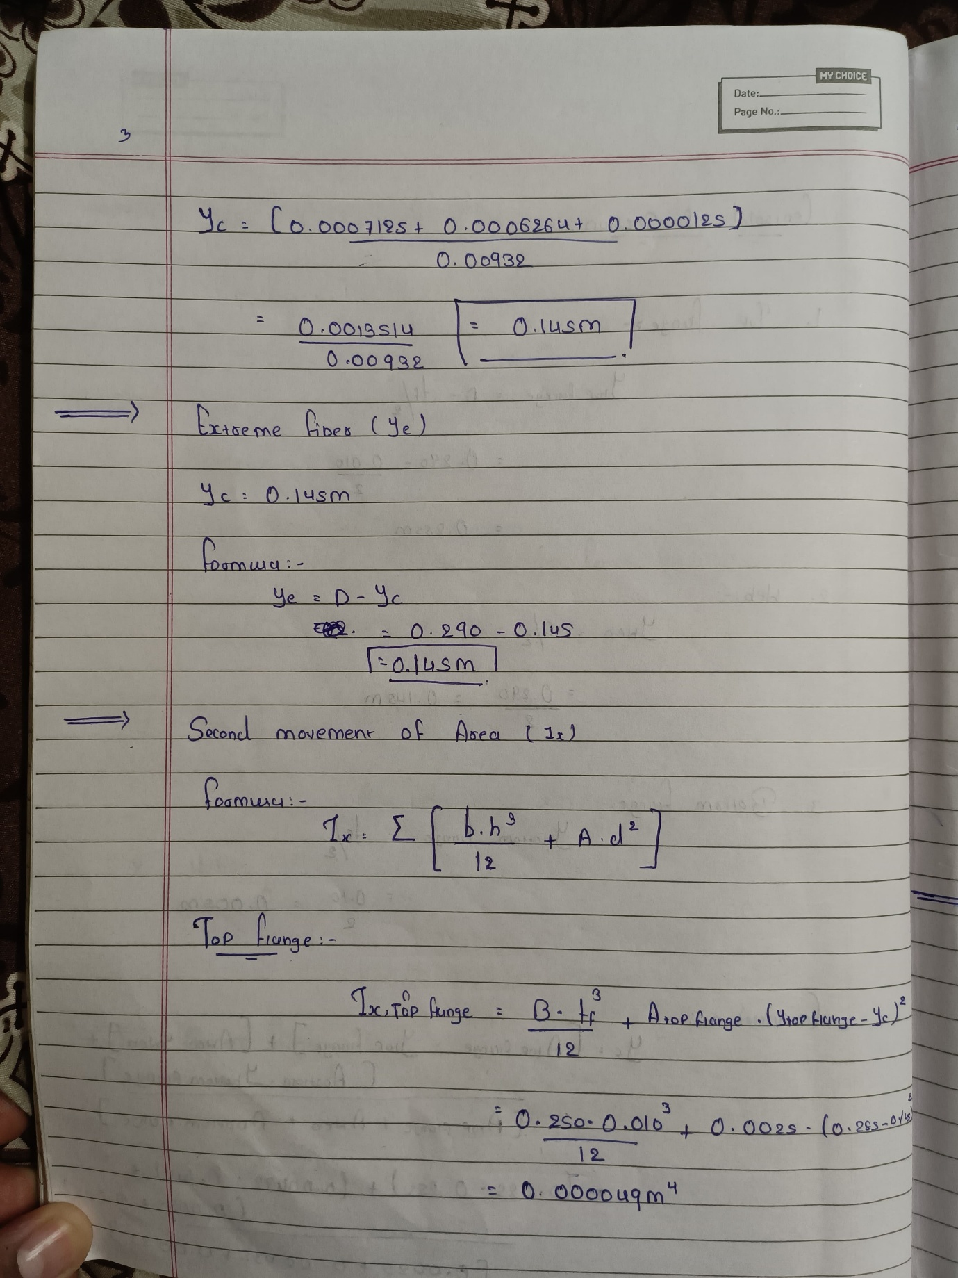

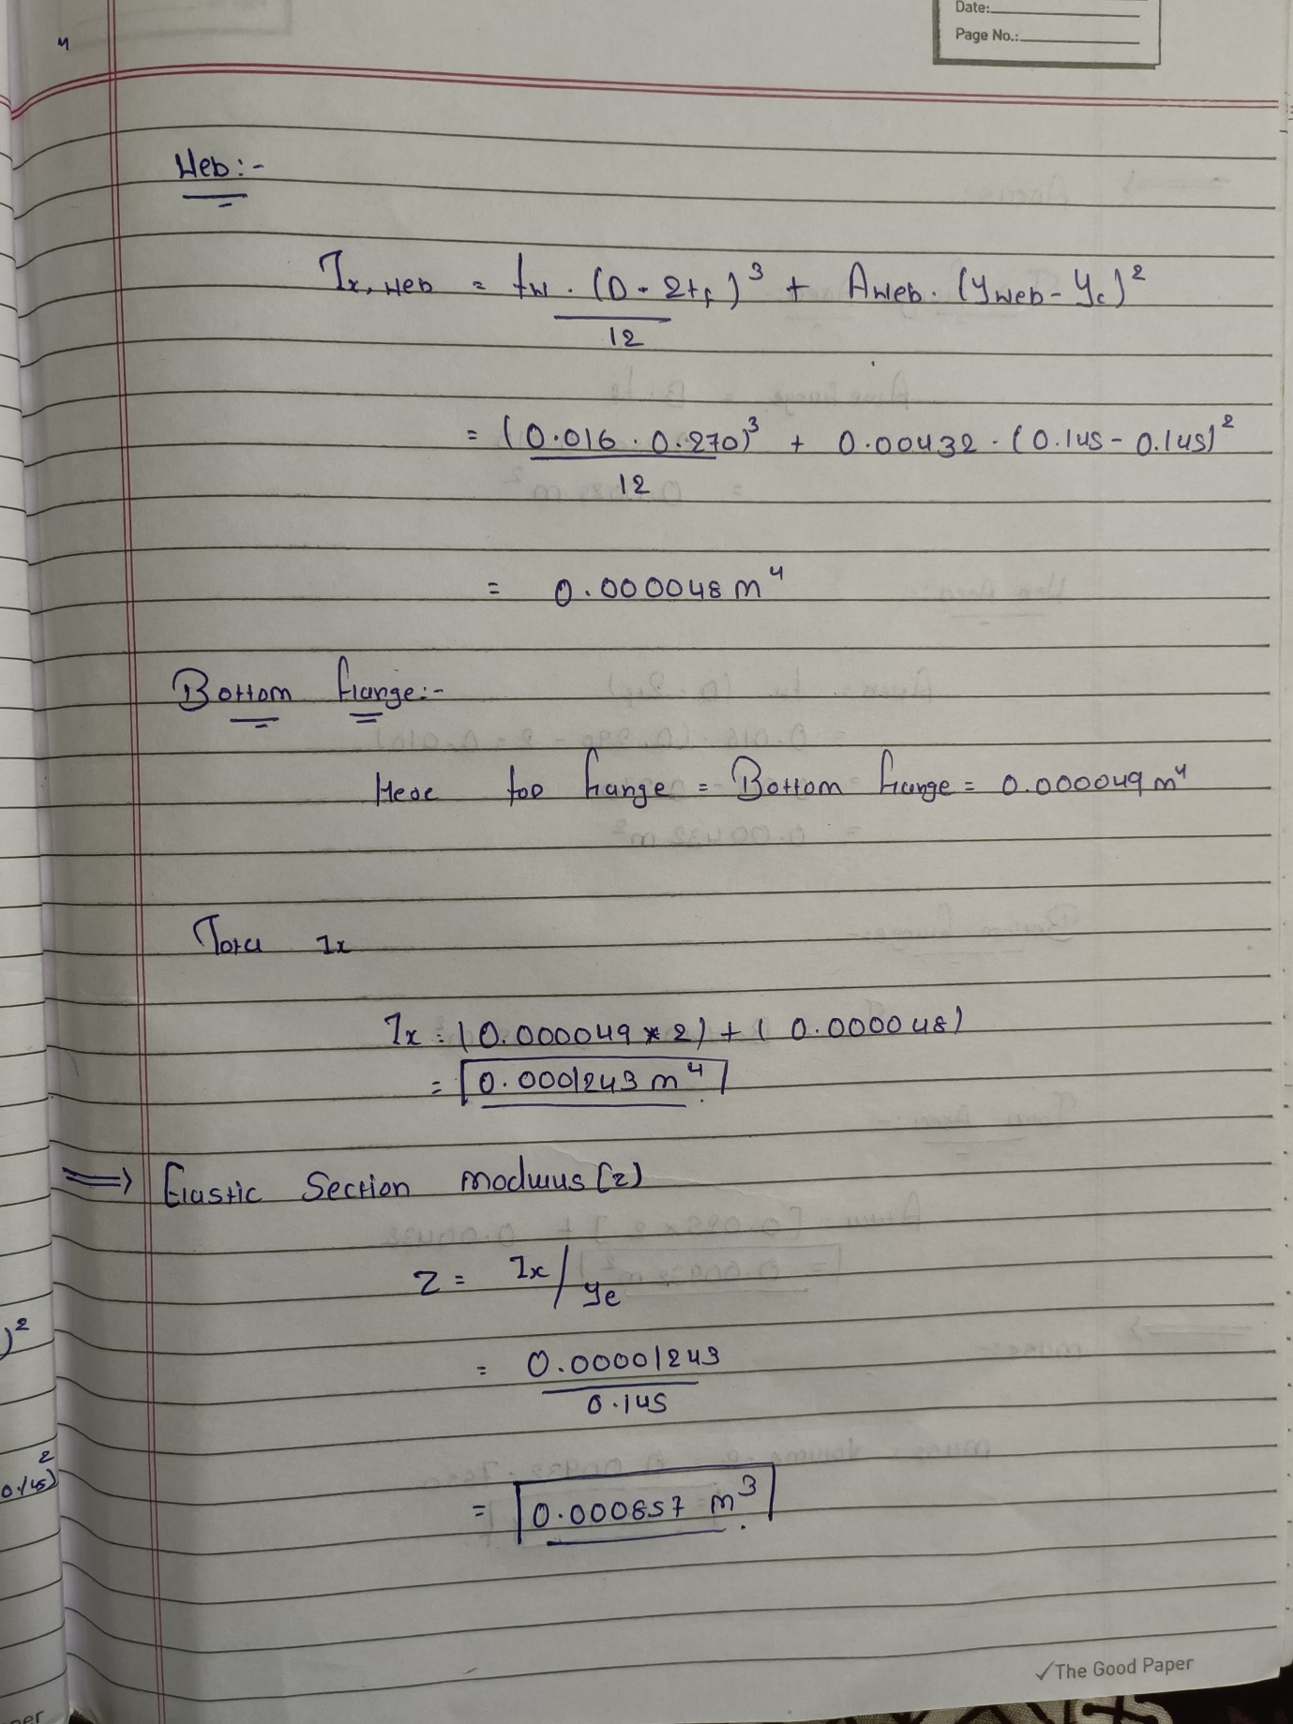

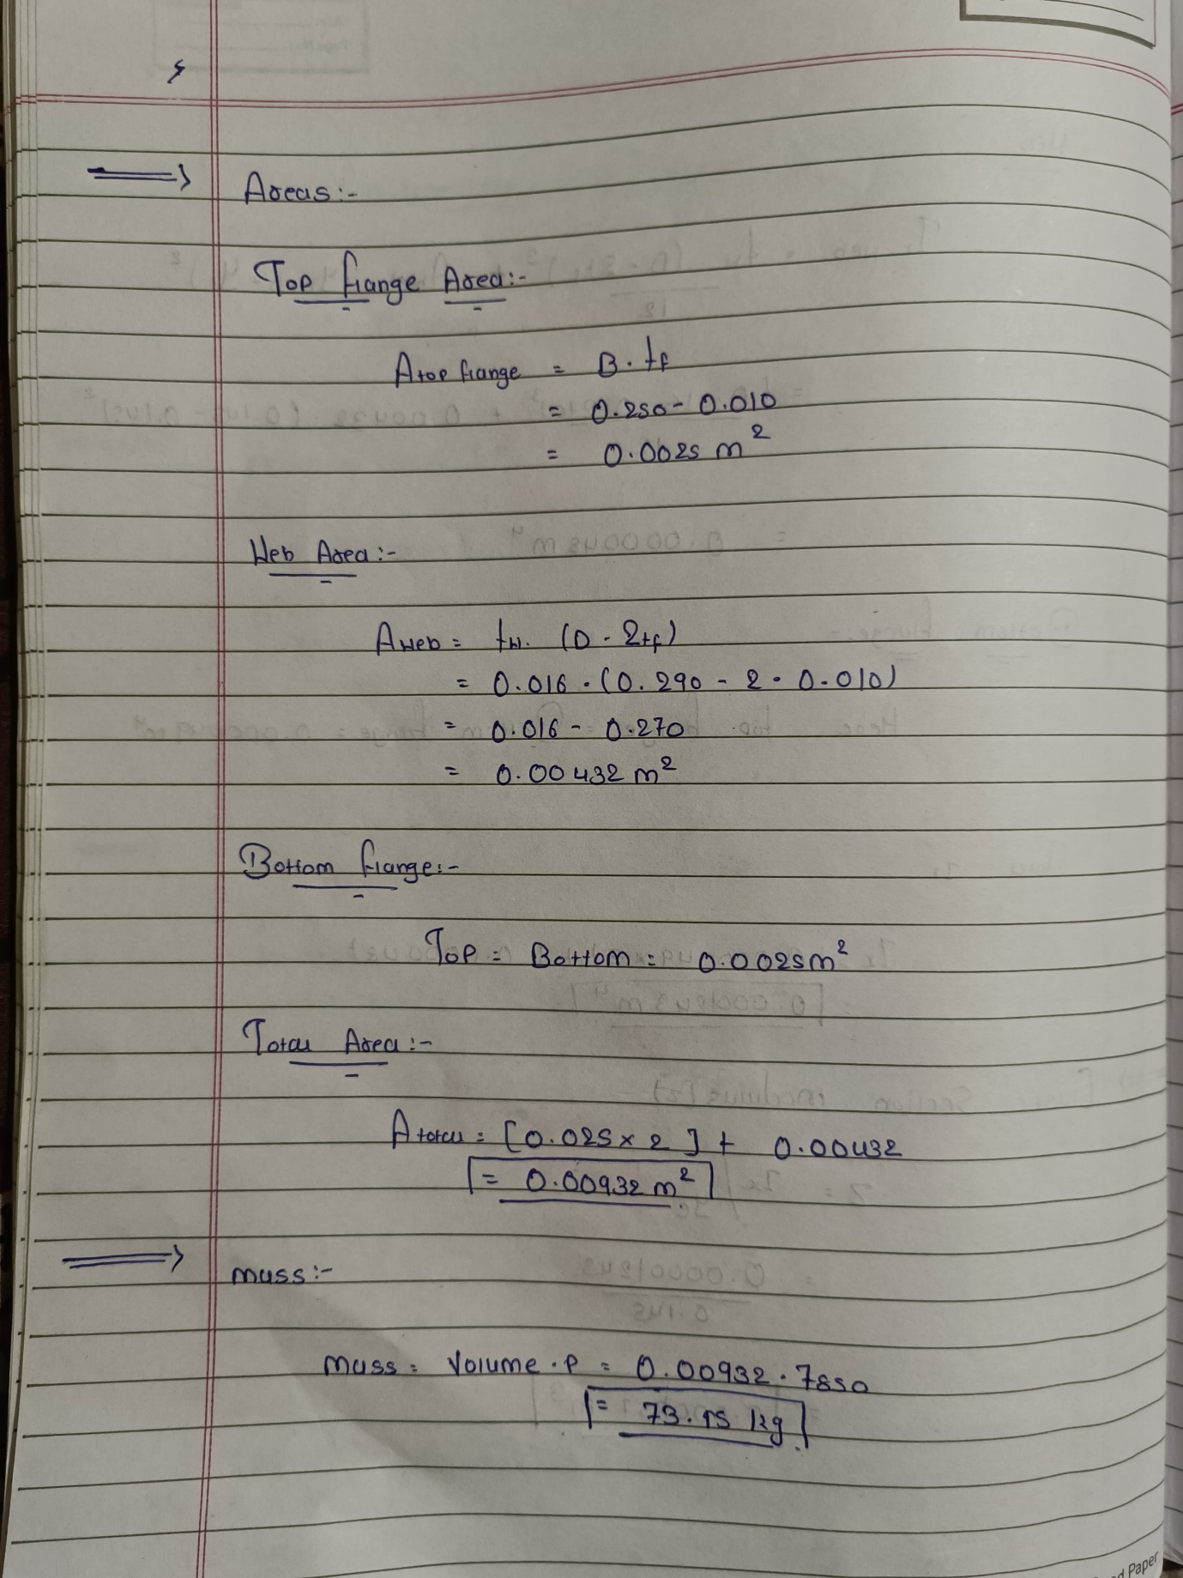

This are the hand written calculation for steel . I also attached pdf of this .

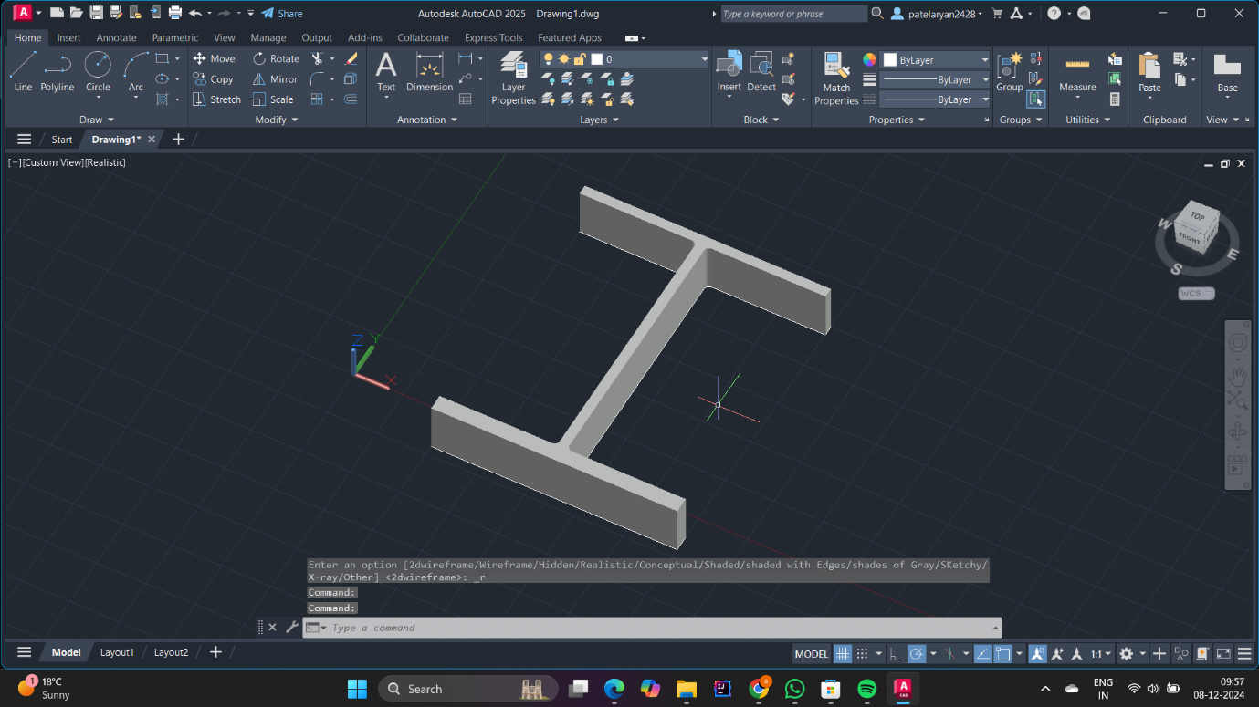

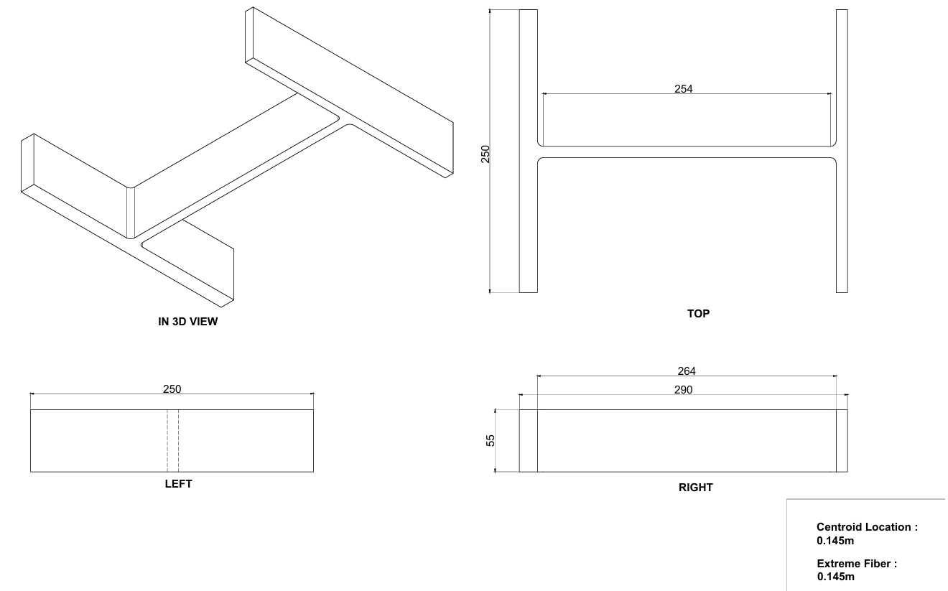

This are the screenshot of autoCAD design of I steel beam . also attached dimension sheet with it .
*All result have been verified and checked using software ‘ tie beam ‘

- Occasion 2:
Design of steel beam for Shear, bending and Bearing capacities. A simply supported beam is constructed using a 360 UB 50.7 Section. Grade 350 Steel. The loading provided is applied on top of the flange.
Draw the Shear force and Bending Moment Diagram for the provided UDL. (No need to calculate the reaction, draw it in terms of Provided W* and l) Design the Steel beam for shear, bending and bearing capacities.

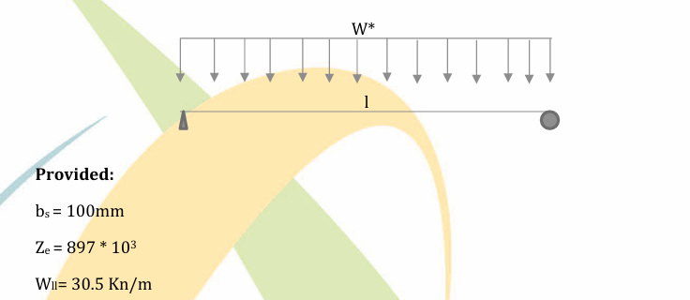

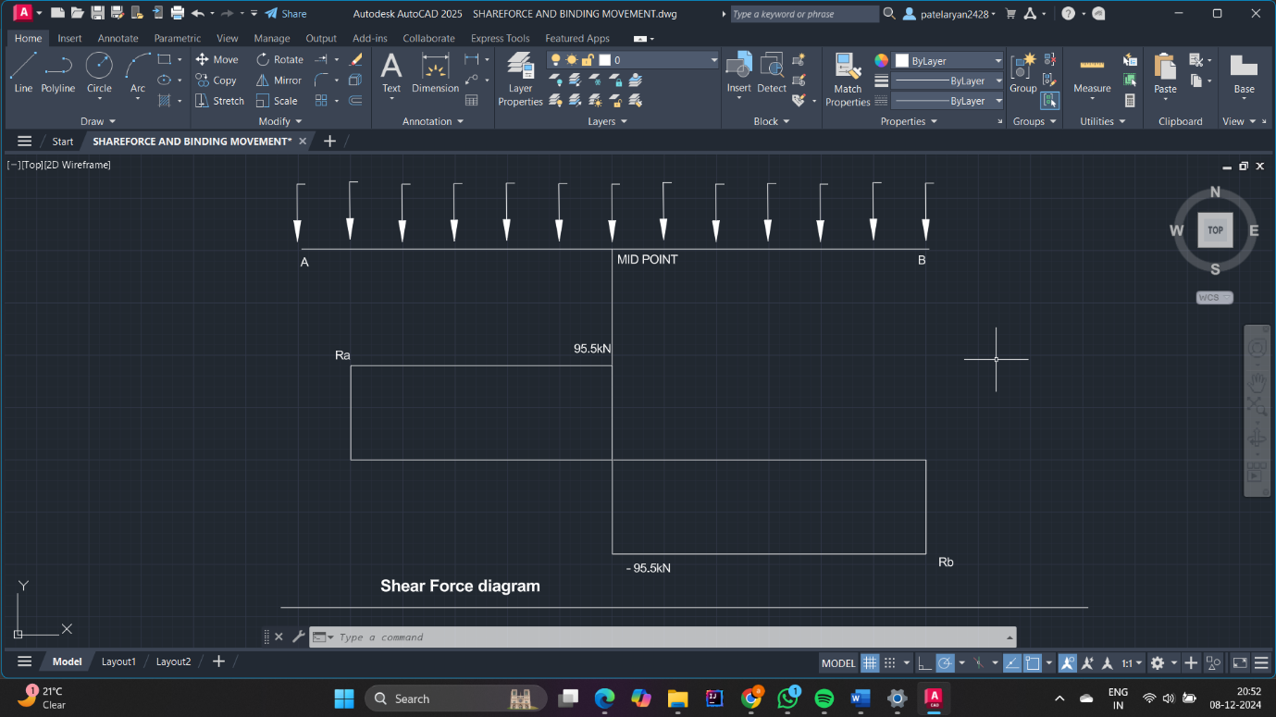
( Shear force diagram )
- Bending movement calculation :
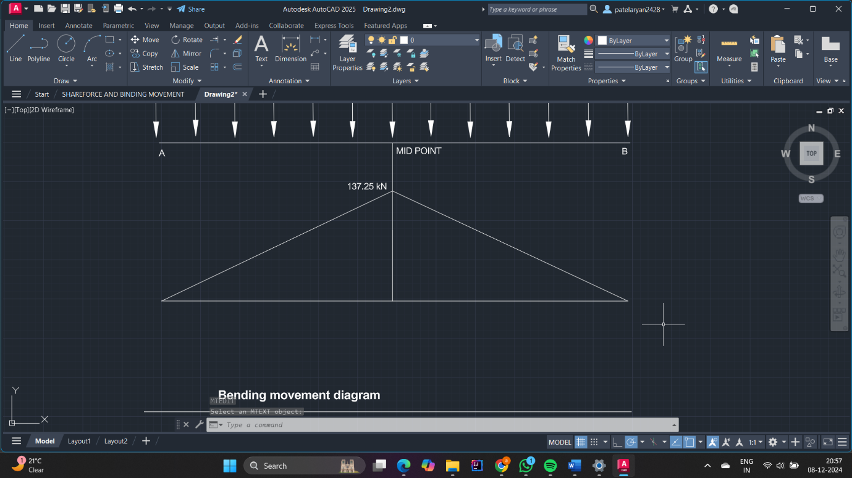
( Bending movement diagram )

*All result have been verified and checked using software ‘ tie beam ‘

Provided values :
B_{s} = 100 mm
Z_{e} = 897*10³
W = 30.5 kN/m
Length = 6mm
Fy (flang) = 340
Fy(web) = 360

- Nominal section moment capacity (M_{s})
M_{s} = Fy*Ze
= 0.34 * 897 = 304.98 kM.m

- Shear capacity calculation
V_{U} = V_{w}
Dp/Tw <= 82 (Fy/250)^{1/2}
333/7.3 <= 82/SQRT (360/250)
45.62 <= 68.33

So V_{U} = V_{w}
= 0.6*Fy*Aw
= 0.6*360*333*7.3
= 525.1

Now ,
Vv = 0.9*525.1
= 472.52
V = 2.1* W
97.33

- Bearing capacity (Rb)

Bearing yield capacity
R_{by} = 1.25*B_{bf} *T_{w} * F_{y}
= 1.25*128.75*7.3*360
= 422.94 kN

- Bearing buckling capacity
from Australian standard 41000 going to t a(b) =0.5
K_{f} = 1.0
R(bb)=a(c)*N(s)
R(bb)=a(c)*K(f)*A(n)*F(y)
A(a)= T(w)*b(b)

B(b) = B(x) + r(ext) + D(5)/2
= 100 + (2.5*11.5) + (332.6/2)
= 295.05 mm

A(a) = 7.1 * 295.05
= 7153.5

Using table we find
Ac = 0.321

R_{bb} = Ac * K_{f} * A_{n} * F_{y}
= 0.321 * 1 * 2155.33 * 360
= 248.86

R(bb) = 248.86 < R(by) = 422.94

Bearing capacity = R(b)
= 0.9 * Rb
= 0.9 * 248.86
= 223.97
- Cost estimation :

Cost Estimation
Item # | Description | Unit | Qty | Rate (A$) | Amount (A$) | Remarks
A | Material
A.1 | Structural Steel | kg |  | 3.88 | -
A.2 |  |  |  |  | -
A.3 |  |  |  |  | -
A.4
A.5
Subtotal (AUD): |  |  |  |  | -
B | Manpower
B.1 | Febricator | Mandays |  | 410.00 | -
B.2 | Welder | Mandays |  | 450.00 | -
B.3 |  |  |  |  | -
B.4 |  |  |  |  | -
Subtotal (AUD): |  |  |  |  | -
C | Equipment
C.1 | Welding Machine | Day |  | 135.00 | -
C.2 | Crane | set |  | 140.00 | -
Subtotal (AUD): |  |  |  |  | -
D | Indirect Cost
D.1 | Overhead | set |  | 340 | 0
D.2 | Utility Cost | LS |  | 115 | 0
D.3 | Administrative Costs | set |  | 225 | 0
D.4
Subtotal (AUD): |  |  |  |  | -
Grand Total AUD (A+B+C+D): |  |  |  |  | -

- References :

- BRANKO E. GORENC, RON TINYOU & ARUN A. SYAM . (2011)

- American Institute of Steel Construction. (2017). Steel construction manual (15th ed.). American Institute of Steel Construction.

- McCormac, J. C., & Csernak, S. F. (2018).

- Timoshenko, S. P., & Gere, J. M. (1972).

- Wang, C., Salmon, C. G., & Pincheira, J. A. (2019).

- Nilson, A. H., Darwin, D., & Dolan, C. W. (2011).

- Zandi, I., & McManus, H. L. (1999).

- Bhavikatti, S. S. (2013). Structural analysis

- Chopra, A. K. (2019).

- Bureau of Indian Standards. (2007).

